Fie P = 503 şi să determinăm log2 241 mod 502=?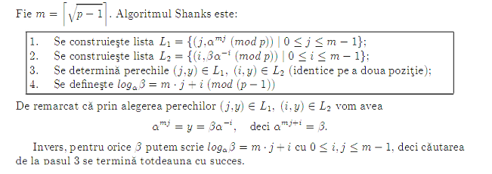

inceput

Realizarea unui caz cand log α β n-are valoare

Avem deci α=2 si β=241 m=22

**Creem listele L1**

(0, 1) (1, 28) (2, 281) (3, 323) (4, 493) (5, 223) (6, 208) (7, 291) (8, 100) (9, 285) (10, 435) (11, 108) (12, 6) (13, 168) (14, 177) (15, 429) (16, 443) (17, 332) (18, 242) (19, 237) (20, 97) (21, 201)

**Creem listele L2**

(0, 241) (1, 372) (2, 186) (3, 125) (4, 298) (5, 138) (6, 326) (7, 163) (8, 333) (9, 418) (10, 209)

(11, 356) (12, 178) (13, 89) (14, 296) (15, 148) (16, 295) (17, 37) (18, 270) (19, 135) (20, 319) (21, 441)

Elementele nu coincide rezulta ca log α β n-are valoare.

SFARSIT